***Experiment No: 05***

***Experiment Name:***

Implementation of LRU page Replacement Algorithm

***Objectives:***

In this we will learn about the LRU page replacement algorithm, its Implementation by using c program and testing the program different inputs and find the outputs.

***LRU (Least Recently Used) Algorithm:***

The Least Recently used (LRU) algorithm replaces the page that has not been used for the longest period of time. It is based on the observation that pages that have not been used for long time will probably remain unused for the longest time and are to be replaced.

***Source Code:***

#include<stdio.h>

void main()

{

int q[20],p[50],c=0,c1,d,f,i,j,k=0,n,r,t,b[20],c2[20];

printf("Enter no of pages: ");

scanf("%d",&n);

printf("Enter the reference string:\n");

for(i=0; i<n; i++)

scanf("%d",&p[i]);

printf("Enter no of frames: ");

scanf("%d",&f);

q[k]=p[k];

printf("\n\t%d\n",q[k]);

c++;

k++;

for(i=1; i<n; i++)

{

c1=0;

for(j=0; j<f; j++)

{

if(p[i]!=q[j])

c1++;

}

if(c1==f)

{ c++;

if(k<f)

{

q[k]=p[i];

k++;

for(j=0; j<k; j++)

printf("\t%d",q[j]);

printf("\n");

}

else

{

for(r=0; r<f; r++)

{

c2[r]=0;

for(j=i-1; j<n; j--)

{

if(q[r]!=p[j])

c2[r]++;

else

break;

}

}

for(r=0; r<f; r++)

b[r]=c2[r];

for(r=0; r<f; r++)

{

for(j=r; j<f; j++)

{

if(b[r]<b[j])

{

t=b[r];

b[r]=b[j];

b[j]=t;

}

}

}

for(r=0; r<f; r++)

{ if(c2[r]==b[0])

q[r]=p[i];

printf("\t%d",q[r]);

}

printf("\n");

}

}

}

printf("\nNo page faults is %d \n",c);

}

***Output:***

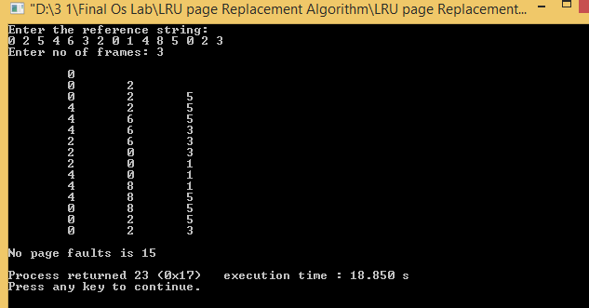

***Discussion:***

In this lab we have learnt about LRU page replacement algorithm. We also have learnt how to implement LRU page replacement by using C programming language.